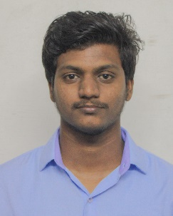Dharani Shankar D

**Cell No:** 8220327756

**Email Id:** [dharanishankard@gmail.com](mailto:dharanishankard@gmail.com)

**Career Objective:**

Seeking a job to use my skills in the best possible way for achieving the company’s goals and to update my knowledge for showcasing better performance for the company.

**Academic Qualification:**

|  |  |  |  |  |
| --- | --- | --- | --- | --- |
| **Qualification** | **University/Board** | **Name of Institution** | **Year of Passing** | **CGPA/ Percentage** |
| B.TECH  (INFORMATION TECHNOLOGY) | Anna University | Velammal Engineering College, Chennai. | 2021 | 8.3 |
| HSC | State board | Velammal Matric Higher Secondary School, Ponneri. | 2017 | 96.6% |
| SSLC | State board | Velammal Matric Higher Secondary School, Ponneri. | 2015 | 91.5% |

**Subject of Interest:**

* Data Structures in C
* Database Management System
* Object Oriented Programming

**Technical Skills:**

* Programming in C, Python
* MySql
* ExpressJS, NodeJS

**Project Details:**

* Food Ordering System using NodeJS, ExpressJS, MongoDB.
* Billing System using php and MySql.

**Achievements:**

* Won 1st place in code relay event held at Loyola -ICAM, Chennai on 17/08/19.
* Won 1st place in web designing event held at TJS Engineering College on 09/03/19.
* Won 3rd place in deadlocked DB event held at Easwari Engineering College, Chennai on 13/02/19.
* Won 1st place in debugging event held at TJS Engineering College on 09/03/19.
* Won 2nd place in codegem event held at RMK Engineering College on 09/03/20.

**Co-curricular activities:**

* Attended industrial visit at BSNL.
* I am an active member of Coders Club, CSI.

**Personal Details:**

**DOB :** 02-01-2000

**Father’s Name :** Devarajan P

**Address**  **:** No 24, Panapakkam Village,

Kolur post,

Ponneri Taluk 601204.

**Languages Known :** English, Tamil